|  |  |
| --- | --- |
| **Project – External Documentation** |  |
| BG01  Computer Graphics |
| Odd Semester Year 2023/2024> |

* Project Title

PLANTS NO ZOMBIE

* Introduction

Plants NO Zombies is a knock-off version of a famous video game Plants vs Zombies created using HTML5 and JavaScript with ThreeJS library. As its’ name, the user will be given a graphic of a zombie and a plant or as we call it, a peashooter. The peashooter will shoot projectiles when user do an on-click. Users are able to change perspectives of the view, by holding the key and drag, or by pressing ‘c’ on the keyboard to change into 1st person camera or to 3rd person camera. Users are also able to change the time setting from day to night by pressing the space bar. It will change the sky from midday to night, with the support of blue skybox and starry night skybox.

* Report / Documentation

1. **Project Outcome**

**First look of Plants NO Zombies (3rd person camera, midday)**

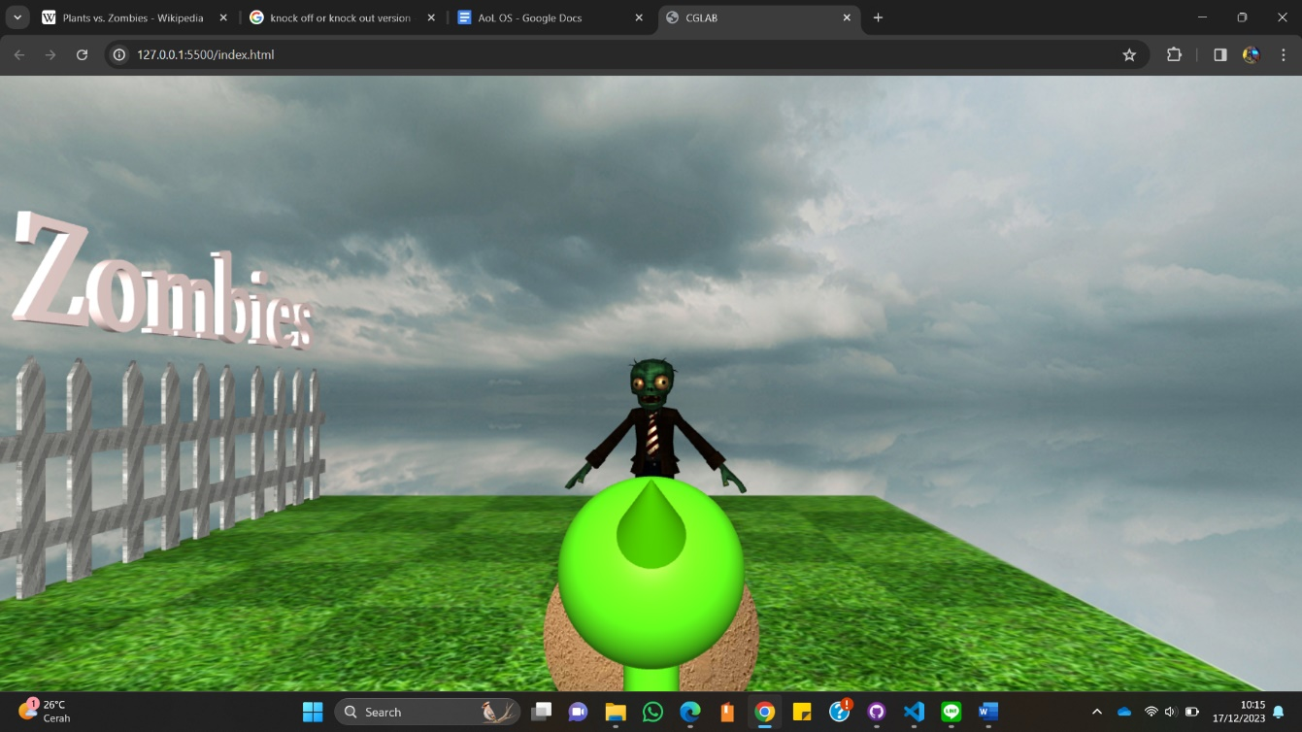

**1st Person Camera**

Users are able to change camera perspective by pressing ‘c’ on keyboard.

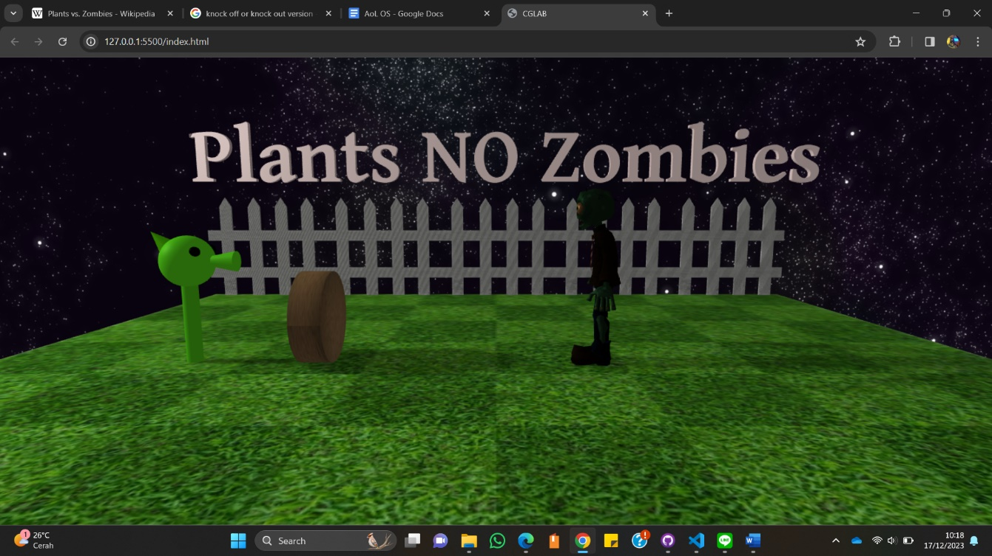

**Nighttime**

Users are able to change time setting from day to night by pressing the spacebar.

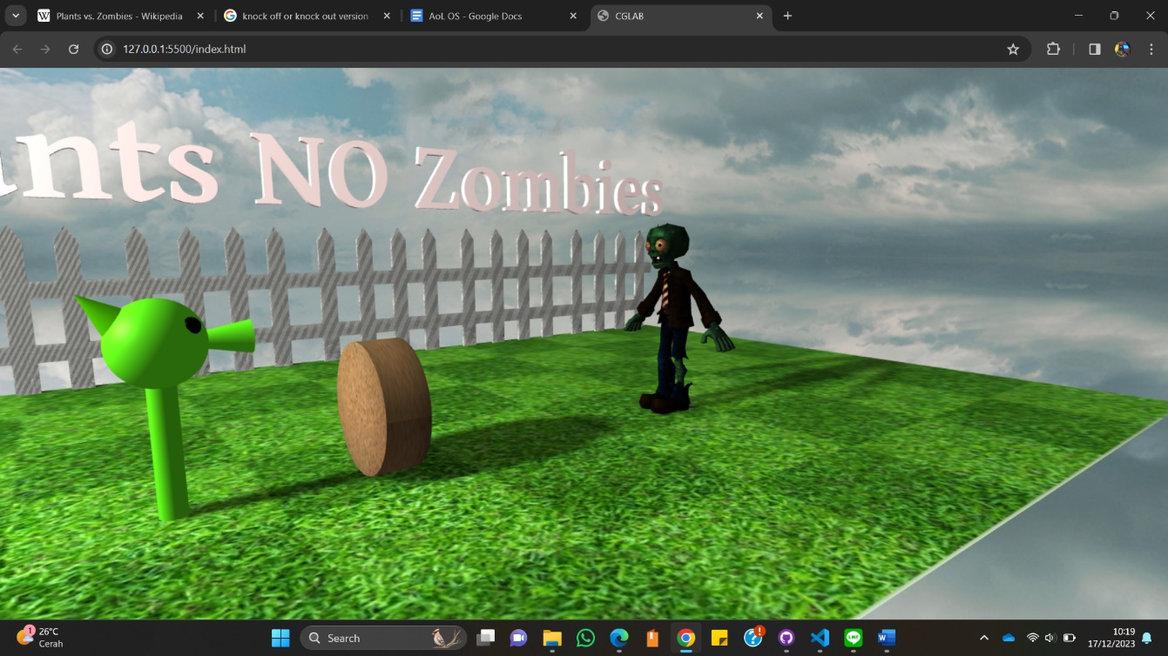

**Change perspective as users wants**

Users are able to change the camera perspective by click and drag the mouse.

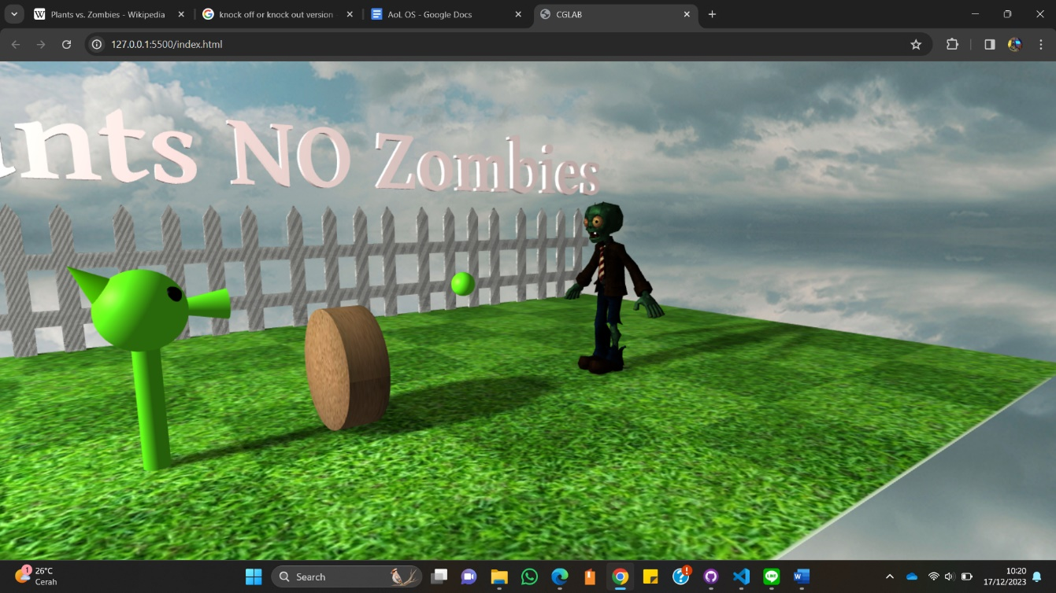

**Peashooter shooting projectile**

Users are able to command the peashooter to attack the zombie by clicking on the screen. The peashooter will shoot projectile as user click.

1. **Screenshot Coding**
   1. **HTML File**

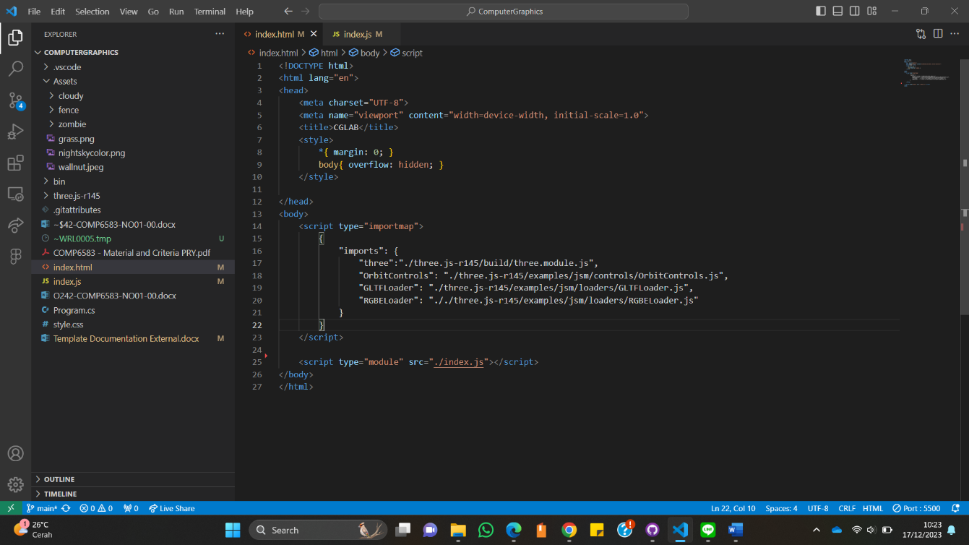

Using HTML5 to declare the libraries and the JavaScript file

* 1. **JavaScript File**

1. **A screenshot of a computer

   Description automatically generatedImport libraries and global variables**

Declare library ThreeJs as THREE as the main library, TRI as the CDN library for the text, import Orbit Controls and GLTF Loader. Declare global variables that will be used frequently thought the program: scene, camera, cameraM, cameraPOV, renderer, controls, geo, mat, mesh, and loader.

1. **Init Function**

Declare the scene, main camera settings, 1st person camera settings. Declare WebGLRenderer as the renderer with antialiasing. Enable the shadowmap using PFC Shadow Map. Declare Orbit Controls focusing on posisition 0, 7, 0 on vector3.

1. **ChangeCam function**

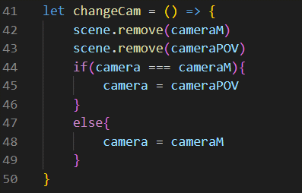

ChangeCam function to switch camera from cameraM (main camera or 3rd person camera) to cameraPOV (1st person camera).

1. **A screen shot of a computer program

   Description automatically generatedGrass function**

Declare grass setting. Using plane geometry to make the grass field with texture. Set the position of the grass to 0, 0, -7.5.

1. **A computer screen with text and images

   Description automatically generatedZombie function**

Declare the zombie using loader (GLTF Loader) from the Assets folder. Set the scale, position, and rotation of the zombie to fit. Enable cast shadow and receive shadow.

1. **Fence function**

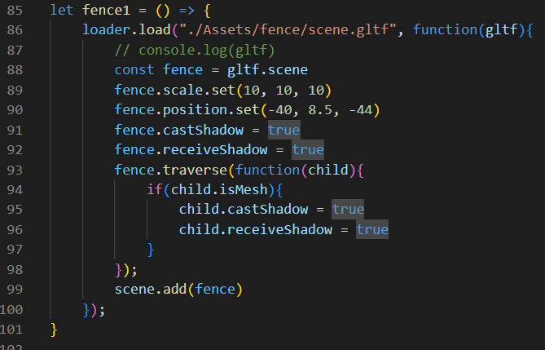

Declare the fence using loader (GLTF Loader) from the Assets folder. Set the scale, position, and rotation of the fence to fit. Enable cast shadow and receive shadow. There are 5 fences, the only difference being the position of the fence.

1. **Text function**

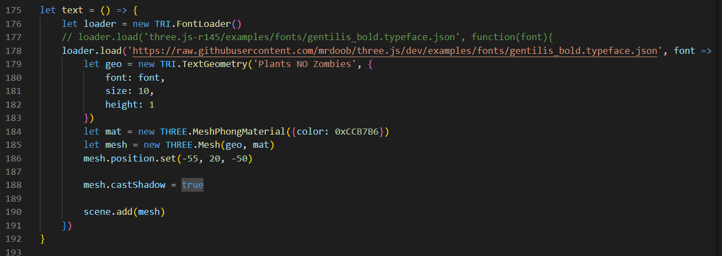

Create a string ‘Plants NO Zombie’ using TextGeometry using gentilis bold as the font. This will be the title.

1. **Peashooter functions**
2. **Head function**

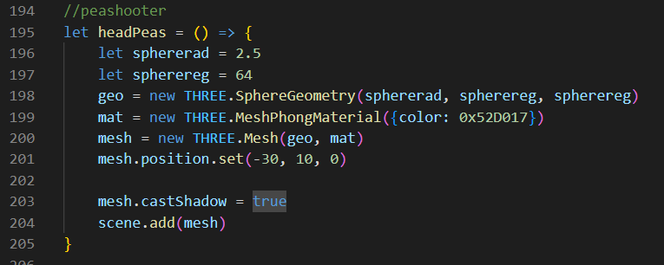

1. **Mouth function**

1. **Top function**

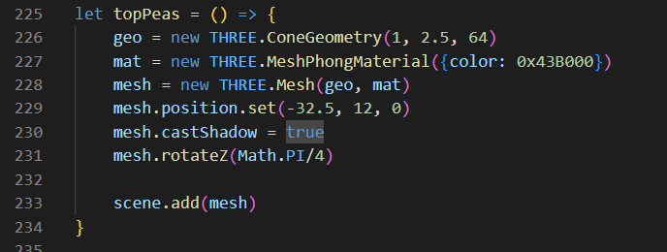

1. **Eyes function**

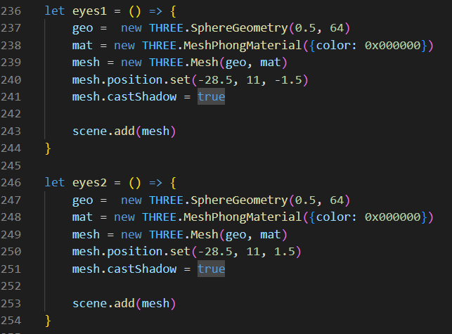

1. **Eyes function**

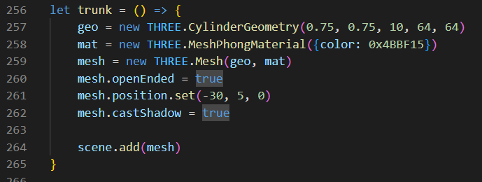

Declare the peashooter by combining those functions.

1. **Walnut function**

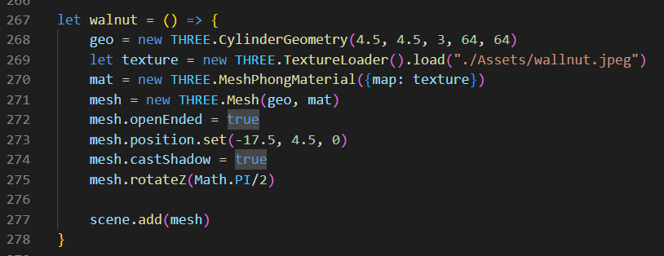

Create a walnut using cylinder geometry and texture. Place the walnut in front of the peashooter.

1. A screen shot of a computer program

   Description automatically generated**Skybox function**



Create a skybox using box geometry and texture. Declare the day skybox as the default. Also declare the spotlight with intensity 1.2 for the day.

1. **Night skybox function**

Create a night skybox using box geometry and texture. Set the intensity of the spotlight to 0.5.

1. 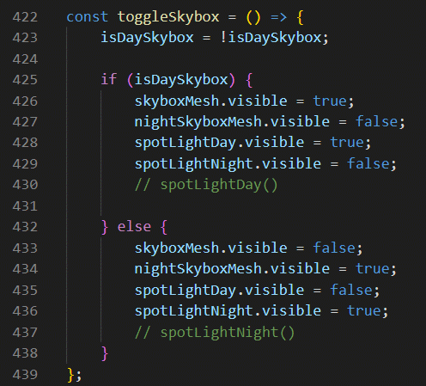**Toggleskybox function**

A function to switch the skyboxes from day to night and vice versa.

1. 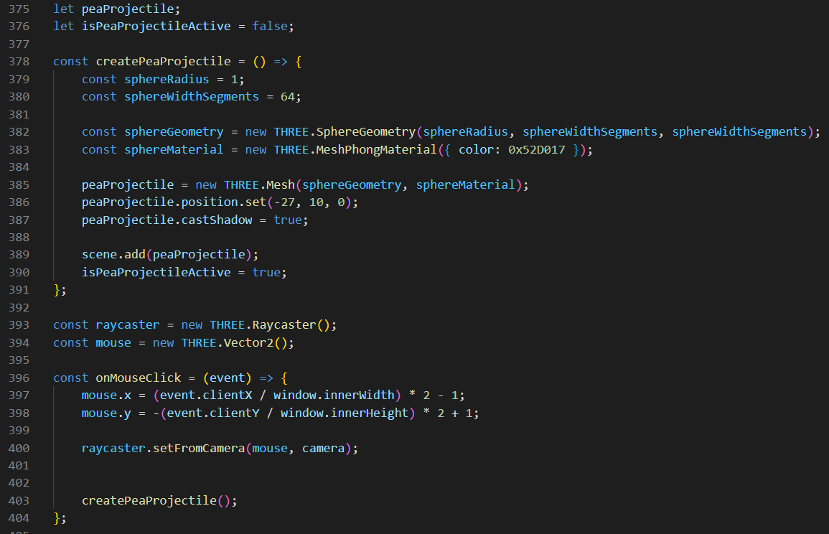**createPeaProjectile and movePeaProjectile function**



A function to create a projectile using sphere. Using onMouseClick function to call the createPeaProjectile function and shoot it in the direction of the zombie when clicking the mouse.

1. 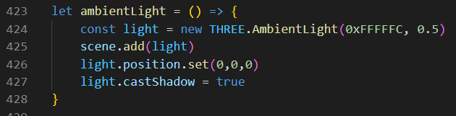**ambientLight function**

Create an ambient light to create the 3d and shadow effect.

1. 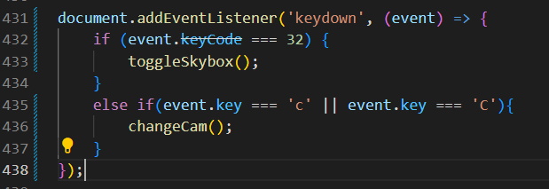**addEventListener**

Use addEventListener to make the keyboard interactions. When pressing spacebar, the skybox will change. When pressing ‘c’, the camera will change.

1. 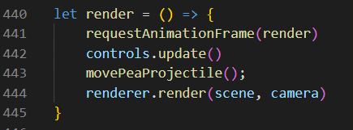**render function**

Use render function to render all the objects.

1. **Window.onload function**

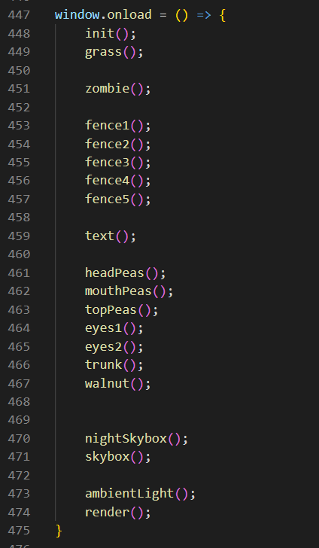

Call all the functions to be displayed.

1. **Window.onresize function**

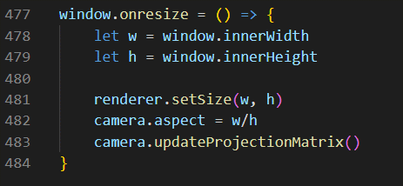

Window.onresize function to resize the display automatically when the screen size is changed.

* Reference
* <https://threejs.org/>
* <https://www.ea.com/games/plants-vs-zombies>
* Group Member
* 2502033462 – CHRISTABEL DIOR POLUAN
* 2502012546 – KEYLA AZZAHRA
* 2502078201 – SEAN LOWELL WIJAYA